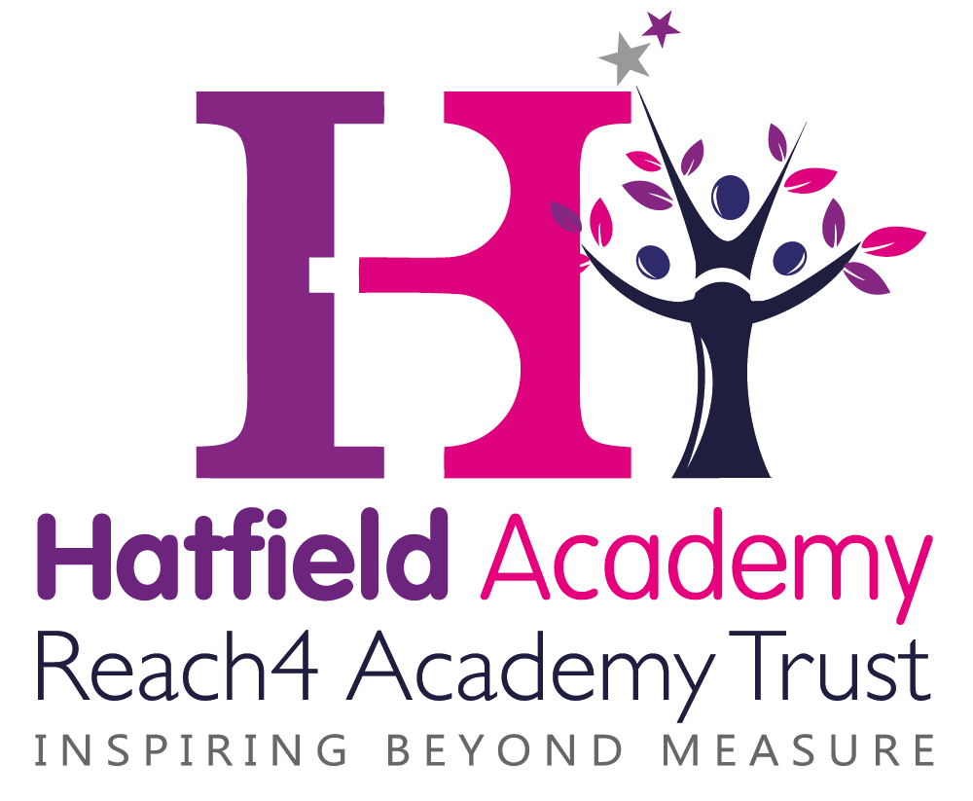

SEND Information

Policy Agreed:

Review Date: September 2017

Hatfield School is part of the Reach4 Academy Trust. We are a mainstream primary school and we admit pupils from age 4 to 11.

Our current Ofsted rating is “Special Measures”

1  What kind of Special Educational Needs are provided for at Hatfield School? | At Hatfield School we provide support for pupils across the 4 areas of need as laid out in the SEND Code of Practice 2015 :  - Communication and interaction  - Cognition and learning  - Social, emotional and mental health difficulties  - Sensory and/or physical needs
2  How do you ensure children who need extra help are identified early? | Pupils are identified as having SEND, and their needs assessed, through :  - Information passed on from other Nurseries and previous primary schools;  - End of Key Stage results and progress data;  - Feedback from teaching staff and observations;  - Pupil Premium interventions not showing impact;  - Referrals from parent/carers  - Specialist assessments can be carried out by Speech and Language Support and the Educational Psychologist.
3a  How do you judge whether the support has had an impact? | Progress meetings are held each half term in which individual children are discussed and their progress evaluated.  - Interventions are tracked at the start and the end to monitor how effective they are.  - Reports are made to the Governing Body.
3b  What arrangements do you have for assessing and reviewing pupils’ progress? | At Hatfield Academy we:  - Track data each half term and hold pupil progress meetings to review individual progress;  - Hold reviews at least three times a year for children who receive SEN support;  - Complete annual reviews for children with EHCPlans or Statements;  - Hold regular parent meetings.
3c  How do you teach children with SEND? | Provision for SEND pupils includes :  - “Quality First Teaching”, with appropriate differentiation in place;  - Extra adult support in classrooms;  - Personalised provision through time limited interventions;  - Personalised provision through the use of resources and specific teaching strategies  - Support from external specialists
3d  How do you adapt the curriculum and learning environment for pupils’ with SEND? | At Hatfield Academy provision includes:  - Small group teaching that targets specific levels of progress;  - Differentiated resources and teaching  - Appropriate choices of texts and topics to suit the learner;  - Access arrangements for tests and or examinations;  - Additional adult support.  - Targeted support and interventions.
3e  How accessible is your school environment? | Hatfield school is a split site with FS/Y1 in the mobile unit and Y2 / KS2 in the main building. There is access to both buildings via ramps.  - Rooms used by pupils are all on one level (ground floor).  - There are disabled toilets in both buildings.  - Classes use visual resources such as visual timetables.  - Reception staff and key support staff are trained in basic Makaton signing which they use to support language development.  - Communicate in Print is used in the Foundation classes when appropriate  - The playground is painted to support children who are visually impaired.  - Training is arranged from specialist teams to support learners with medical needs such as diabetes, epilepsy and allergies.  - There are personalised interventions for children who need additional social and emotional support.  - Teachers deliver differentiated lessons to ensure that all children of differing abilities are catered for.
3f  How do you support the development of good social, emotional and mental health for children with SEND? | At Hatfield Academy we offer:  - An anti-bullying policy that is supported by annual anti-bullying week / Online Safety Week  - Learning Mentors and Support Workers trained in interventions such as Self Esteem, Mental Health First Aid and supporting Attachment Disorder.  - Targeted support for individual pupils via the Inclusion Team.  - Pupil Voice via the School council  - Specialist support from the MAST team, CAMHS and the Educational Psychologist. Hatfield School purchases an package of support from an private Educational Psychology service  - A Designated Safeguarding Lead who provides a strong link between parent/carers and school.
4  Who is your SEND Co-ordinator? | Our SEND co-ordinator is:  Beth Marriott (Director of Inclusion)  0114 245 6871  SENHatfield@hbhacademytrust.org  We also have an Assistant SEND Co- ordinator  Anita Linley  01142456871
5  What training have the staff supporting children with SEND had, or are currently having? | Staff have accessed training in the following areas:  - Use of Numicon to support maths  - Supporting Dyslexia  - Delivery of interventions such as Alphabet Arc, Acceleread/Accelewrite, First Class @ Number, Toe by Toe and Fine Motor Skills.  - Specific language interventions such as LEAP and TalkBoost.  - Phonics  - Supporting children with ASD  - Lego Therapy  - Team Teach training.  - Supporting the behaviour of children with communication difficulties  We have staff who have been trained by the Speech and Language Team to deliver specific language programmes such as the Language Enrichment Activity Programme (LEAP), TalkBoost, Vocabulary Intervention Programme (VIP), Narrative Intervention Programme (NIP), Sentence Maker and REACT 2  Hatfield Academy acknowledges that we need specialist advice and so therefore we buy in enhanced support packages from external agencies such as an private Educational Psychology Service and the Speech and Language Team. We work closely with agencies such as MAST, the Hearing Impaired Service and the Autism Service.  Training for medical needs within school is updated annually or as needed.  7 members of staff are trained in basic first aid . 5 members of staff are trained in paediatric first aid
6  How will equipment and resources be secured? | - Pupil Premium Funding  - Charities  - SEND Higher level Funding  - Support Services
7  How are parent/carers involved? | Hatfield school is committed to building strong working relationships with parent/carers. We do this in a variety of ways including:  - Newsletters  - Attendance newsletters  - SEND Parent Drop-ins  - Texts about key events  - Parent/Carer workshops  - Parent evenings  - Family Learning  - Celebration assemblies  - Termly SEND reviews  - Annual reviews for children with EHC plans/statements of educational need  - Using interpreters for meetings on request (Language Line)  - Parent Workshops  - GAP intervention – this is an opportunity for parents to work in partnership with the Inclusion team to develop strategies in supporting children who struggle with routines and boundaries.
8  How can my child give his/her views about their education? | - School council  - SEND reviews  - Annual reviews
9  How are complaints dealt with? | See complaints procedure
10  How are the Governors involved and what are their responsibilities? | - The Director of Inclusion contributes information termly which is presented at the Governors meetings.  - The Governors agree priorities for spending within the SEND budget to ensure all children receive the support they need.
11  What specialist services are available to the school? | - We work closely with outside agencies such as Ryegate, the Nursing Team, MAST, CAMHS, the Autism Service, the Hearing Impaired Service, speech and Language Therapy and Social Care.  - Hatfield School buys in support from an Educational Psychology Service.
12  How do you support pupils’ with SEND in transition? | At Hatfield School we support transition in a variety of ways including:  - Inductions for children starting in our foundation.  - Inductions with key staff for pupils transferring to us mid- term.  - Social stories / transition booklets are used to support children with SEND as they move to the next year group.  - Transition weeks are planned to allow children to get to know their new teachers. Extra visits are planned for children with SEND.  - Transition visits with secondary schools and meetings between key staff co-ordinated by our Assistant SEND co-ordinator  - Prompt transfer of information – all information relating to Child Protection and SEND is passed on to the new school quickly.
13  Where is your “Local Offer” published? | The “Sheffield Local Offer” is available on the Sheffield City Council Website

