Attendance
and
Punctuality
Policy

Policy Agreed: May 2018
Review Date: May 2019

Aims

Our school aims to meet its obligations with regards to school attendance by:
- Promoting good attendance and reducing absence, including persistent absence
- Ensuring every pupil has access to full-time education to which they are entitled
- Acting early to address patterns of absence
- Improving the overall attendance percentage of students at the academy to above the national average
- Providing support, advice and guidance to parents and students
- Promoting effective partnerships with other services and agencies

We will also support parents to perform their legal duty to ensure their children of compulsory school age attend regularly, and will promote and support punctuality in attending lessons.

Key Attendance Categories at Hatfield Academy are:

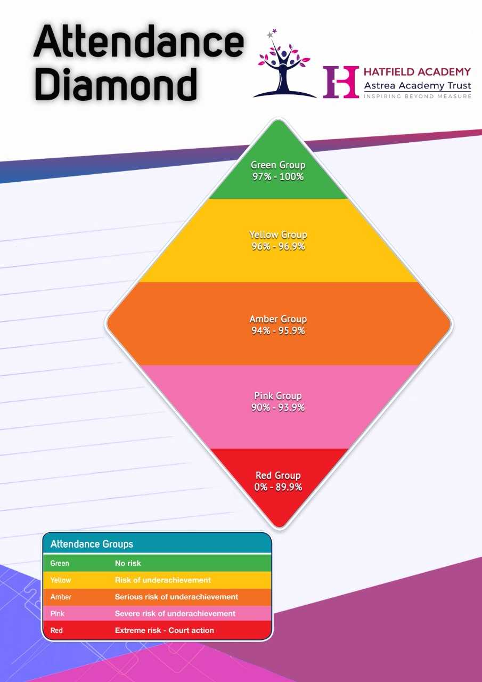

School procedures
Attendance register
By law, all schools (except those where all pupils are boarders) are required to keep an attendance register, and all pupils must be placed on this register.
The attendance register will be taken at the start of the first session of each school day and once during the second session. It will mark whether every pupil is:
- Present
- Attending an approved off-site educational activity
- Absent
- Unable to attend due to exceptional circumstances

Any amendment to the attendance register will include:
- The original entry
- The amended entry
- The reason for the amendment
- The date on which the amendment was made
- The name and position of the person who made the amendment
See appendix iii for the DfE attendance codes.

Every entry in the attendance register will be preserved for 3 years after the date on which the entry was made.
Pupils must arrive in school by 8.30am on each school day.
Teachers will collect their class from the yard at 8.35am
The register for the first session will be taken at 8.45am and will be kept open until 9.15am.
The register for the second session for EY and KS1 will be taken at 12.30pm and will be kept open until 12.35pm.
The register for the second session for KS2 will be taken at 1pm and will be kept open until 1.05pm.

Unplanned absence
Parents must notify the school on 0114 245 6871 (Option 1), on the first day of an unplanned absence – for example, if their child is unable to attend due to ill health – by 9am or as soon as practically possible.
Absence due to illness will be authorised unless the school has a genuine concern about the authenticity of the illness.
We will ask parents to provide medical evidence, such as a doctor’s note, prescription, appointment card or other appropriate form of evidence.
If the school is not satisfied about the authenticity of the illness, the absence will be recorded as unauthorised and parents will be notified of this in advance.

Medical or dental appointments
Missing registration for a medical or dental appointment is counted as an authorised absence; advance notice is required for authorising these absences.
However, we encourage parents to make medical and dental appointments out of school hours where possible. Where this is not possible, the pupil should be out of school for the minimum amount of time necessary.

Signing Out
If a student has to leave the academy during the day for any reason then a signed note from parents is required in advance of the date. Attendance to school is expected either side of any appointment.

Lateness and punctuality
A pupil who arrives late but before the register has closed will be marked as late, using the appropriate code.
A pupil who arrives after the register has closed will be marked as absent, using the appropriate code.

Following up absence
The school will follow up any absences to ascertain the reason, ensure proper safeguarding action is taken where necessary, identify whether the absence is approved or not and identify the correct attendance code to use.

Pupils Transferring from the Academy
An exit strategy is in place for all pupils who leave the academy. This strategy is prompted by the completion of Common Transfer Form.
When the CTF is completed, Education Welfare Officer begins to monitor the attendance of the pupil until the first day of non-attendance.
On the first day of non-attendance by the pupil, the Education Welfare Officer will contact the transfer school to follow up if this pupil has been placed on roll.
If the pupil is on roll at the new school, Education Welfare Officer will collect the DCSF number and pass onto the Office Manager, who will forward on the CTF.
Education Welfare will then remove the child from roll, entering the date of leaving and destination after leaving.

Reporting to parents
At the end of the academic school year we will report attendance through the end of year report.

Authorised and Unauthorised Absence
Granting approval for term-time absence
Principals may not grant any leave of absence to pupils during term time unless they consider there to be 'exceptional circumstances'.
The school considers each application for term-time absence individually, taking into account the specific facts, circumstances and relevant context behind the request. A leave of absence is granted entirely at the Principal’s discretion. In those cases where leave is not authorised and the student still goes on holiday the absence will count as unauthorised and prosecution may result.
Valid reasons for authorised absence include:
- Illness and medical/dental appointments – as previously explained
- Religious observance – where the day is exclusively set apart for religious observance by the religious body to which the pupil’s parents belong. If necessary, the school will seek advice from the parents’ religious body to confirm whether the day is set apart
- Traveller pupils travelling for occupational purposes – this covers Roma, English and Welsh Gypsies, Irish and Scottish Travellers, Showmen (fairground people) and Circus people, Bargees (occupational boat dwellers) and New Travellers. Absence may be authorised only when a Traveller family is known to be travelling for occupational purposes and has agreed this with the school but it is not known whether the pupil is attending educational provision
- Where these are academy directed e.g. educational visits (V) or sporting activities (P) they will constitute a present mark. In the case of activities personal to an individual student e.g. music exams or special tuition the academy will exercise its discretion to authorise the absence.

Family Holidays
From the 1st September 2013, the Department for Education amended the regulations surrounding holidays in term time. They removed references to family holiday and extended leave as well as the statutory threshold of ten school days.
These new amendments make it clear that the Principal may not grant any leave of absence during term time unless there are exceptional circumstances, and gives no entitlement for parents/carers to take their child on holiday during term time.
If leave is required due to an exceptional circumstance a written request must be submitted to the Principal who will make the decision to grant leave.

Excluded Students
Where a student has been excluded for a fixed term their absence will be treated as authorised. In the case of a permanent exclusion absence will also be treated as authorised while a review is in progress. Where a student fails to attend a reintegration meeting their absence will be marked as unauthorised.

Legal sanctions
Schools can apply via the Local Authority to fine parents for the unauthorised absence of their child from school, where the child is of compulsory school age.
If issued with a penalty notice, parents must pay £60 within 21 days or £120 within 28 days. The payment must be made directly to the local authority.
The decision on whether or not to issue a penalty notice ultimately rests with the Principal, following the local authority’s code of conduct for issuing penalty notices. This may take into account:
- A number of unauthorised absences occurring within a rolling academic year
- One-off instances of irregular attendance, such as holidays taken in term time without permission
- Where an excluded pupil is found in a public place during school hours without a justifiable reason
If the payment has not been made after 28 days, the local authority can decide whether to prosecute the parent or withdraw the notice.

Strategies for promoting attendance
Parents of pupils who are persistently late or whose attendance is causing concern will be contacted by the school and attendance processes will occur.

Monitoring
Telephone Calls Received from Parents
When a call is received reporting a child absent an ‘N’ mark should be inputted onto the register and a comment added.
The Attendance Officer will decide from this comment whether the mark will be authorised/unauthorised of if a follow up call needs to be made, based on the information received and previous discussions at meetings.
Where no telephone call has been received, a first day call will take place for every child. A home visit may also be carried out where no reason has been provided for absence, or there are concerns in relation to Attendance or Safeguarding.
First day response
If a pupil is absent and contact has not been made by the parent by 8.30am, a first day telephone call will be made. A further call will be made if the absence continues to 3 days.

Initial Meeting
All pupils with attendance below 93% will receive an initial concern letter, with a 2 week monitoring period for improvement to be made.
If further absences occur over this monitoring period, parents will be invited to an initial meeting with the Academy Education Welfare Officer (Mrs Gibson). The meeting will give the opportunity to discuss any concerns, provide medical evidence and action and offer support if required
If parents fail to attend the meeting without requesting an alternative date/time, the meeting will still go ahead in their absence

School Attendance Panel (SAP) Meeting
If attendance does not improve following the initial meeting a follow up meeting will be held with the Academy Education Welfare Officer and the Principal.
- If parents fail to attend the meeting without requesting an alternative date/time, the meeting will still go ahead in their absence
- The meeting will consider why improvements have not been seen, what medical evidence is required and what support can be offered
- Legal action will also be considered at this meeting which may result in a fine and/or summons to court

External Support
During the initial and School Attendance Panel meetings, external support from the Local Authority Multi-Agency Support Team (MAST) will be discussed and referrals made where required.

Medical Evidence
Where medical evidence has not been available regarding a child’s illness, a discussion will be held at the follow up meetings regarding parents consenting to the Local Authority requesting this details form the GP.

Children Missing from Education (CME)
Children are considered to be ‘Missing from Education’ when they have missed 20 consecutive school days, with no reason provided. At this point the school must carry out the CME procedures, including checks with the Local Authority, HMRC, Social Care and schools attended by siblings. If the pupil can still not be found and contact with parents has been unsuccessful the school will request that the child is removed from roll.

Home Education
Parents considering home education must provide written and signed confirmation to the school. Upon receipt the child would automatically be removed from roll and a referral would be made to the Local Authority.
At Hatfield Academy we reward good attendance.

Attendance Rewards
Termly
 | Autumn  (September – December | Spring  (January – April) | Spring  (September – April) | Summer  (May-July) | Summer  (September – July
100% | Certificate & Attendance Pencil  Key Stage Reward – Attendance Disco | Certificate & Attendance Pencil  Key Stage Reward – Film Afternoon | Certificate & Attendance Badge  Key Stage Reward – Film Afternoon | Certificate & Attendance Pencil  Key Stage Reward – Attendance Picnic | Certificate & Attendance Medal  Key Stage Reward – Attendance Picnic
96% + | Certificate  Key Stage Reward – Attendance Disco | Certificate  Key Stage Reward – Film afternoon |  | Certificate  Key Stage Reward – Attendance Picnic

Weekly
Each week children with 100% attendance are entered into a raffle. A child from EY / KS1 and a child from KS2 are presented with a voucher in Attendance Assembly.
The class with the highest attendance receive the attendance trophy, an attendance sticker and are rewarded with 10 minutes extra playtime (at the discretion of the teacher.

Attendance Display
Each classroom will have an attendance display:
Class teachers will celebrate pupils who attend school every day.
Class attendance will be displayed on the attendance display and updated weekly.
The school target attendance percentage will be displayed on the attendance display.
A display in reception area will share:
- Key attendance messages
- Classes ordered by attendance
- School targets and figures

Social Media
We will blog the attendance winners weekly, both individuals and classes.

Attendance monitoring
The Education Welfare Officer monitors pupil absence on a daily basis.
Parents are expected to call the school in the morning if their child is going to be absent due to ill health.
If a pupil’s absence goes above 3 days we will contact the parents to discuss the reasons for this.
If after contacting parents a pupil’s absence continues to rise, we will consider involving a Local Authority Attendance & Inclusion Officer .
The persistent absence threshold is 10%. If a pupil's individual overall absence rate is greater than or equal to 10%, the pupil will be classified as a persistent absentee.
Pupil-level absence data is collected each term and published at national and local authority level through the DfE's school absence national statistics releases. It is also collected by the Trust. The underlying school-level absence data is published alongside the national statistics. We compare our attendance data to the national average, and share this with governors.
Attendance Data is stored and tracked at Hatfield, by the Education Welfare Officer. This information is used to monitor specific groups of children, and/or those whose attendance is a concern. Intervention can then be put in place as appropriate.

Roles and responsibilities
Trust board
The trust board is responsible for monitoring attendance figures for the whole school on at least a termly basis. It also holds the Principal to account for the implementation of this policy.

Principal
The principal is responsible for ensuring this policy is implemented consistently across the school, and for monitoring school-level absence data and reporting it to governors.
The principal also supports other staff in monitoring the attendance of individual pupils and issues fixed-penalty notices, where necessary.

Education Welfare Officer
The EWO:
- Monitors attendance data at the school and individual pupil level
- Reports concerns about attendance to the principal
- Works with education welfare officers to tackle persistent absence
- Arranges calls and meetings with parents to discuss attendance issues
- Advises the principal when to issue fixed-penalty notices, and completes the necessary paperwork

Class Teacher
Class teachers are responsible for recording attendance on a daily basis, using the correct codes, and submitting this information to the school office.

Office staff
Office staff are expected to take calls from parents about absence and record it on the school system.

Monitoring arrangements
This policy will be reviewed annually by the Education Welfare Officer. At every review, the policy will be shared with the governing board.

Links with other policies
This policy is linked to our child protection and safeguarding policy

Appendix i
Hatfield Academy Attendance Process and Sanctions

NO IMPROVEMENT
NO IMPROVEMENT
IMPROVEMENT
IMPROVEMENT
Stage 2 - Meeting will be held, discussion with parents and a review period set. If no improvement is made during review period - (Stage 3).
Stage 3 - During the review period if attendance drops to below 90%, a letter will be sent to parents informing them they must attend a SAP (School Attendance Panel) meeting which will be chaired by the Local Authority.
If improvement is made during the review period, this will be discussed with parents at the review meeting and the child returned to normal monitoring.
Stage 1 - A letter will be sent to parents explaining that their child’s attendance will now be monitored for 2 weeks and if no improvement is made, they will be invited in for a meeting with the Attendance Officer (Stage 2)
Stage 3 - Meeting will be held, discussion with parents and outcomes agreed
Stage 2 - If there is no significant improvement and if further absences occur, parents will be invited into school to meet with the Attendance Officer.
If improvement is made during the 2 week period, the child will return to normal monitoring and an improvement letter sent to parents.
Any pupil whose attendance drops to between 93% and 90% is at risk of becoming a Persistent Absentee.

Stage 3 - Meeting will be held, discussion with parents and outcomes agreed. School will not authorise any future absences unless medical evidence is provided. Child’s attendance will be monitored and any future unauthorised absences may result in a fixed penalty or a summons to court.

Appendix ii

Hatfield Academy Attendance Process and Sanctions
Holidays during term-time
If you take your child on holiday in term time without their Principal’s authorisation, you may be issued with a FIXED PENALTY NOTICE (a fine)!
Normally this will be one fine per parent regardless of the number of children in the family being taken on holiday. Each parent/carer can be issued with a Penalty Notice fine, regardless of whether they went on the holiday with the child or not.

What must I do?
Inform school Attendance Officer when your child will be absent from school by completing a Request for Exceptional Leave form. This must be completed at least 4 weeks before the proposed start date of the holiday and must state the reason for the absence. The Principal will decide whether this can be authorised, booking a holiday first is not an acceptable reason for authorisation.

From the 1st September 2013, the Department for Education amended the regulations surrounding holidays in term time. They removed references to family holiday and extended leave as well as the statutory threshold of ten school days.

Is my child entitled to time off school for family holidays?

No. Parents/Carers do not have the right for their child to have leave of absence for a holiday. The Principal has a discretionary power to grant leave under exceptional circumstances but is under no obligation to do so.

You MUST provide a return date to the school at the time of requesting the period of leave. Failure to do so will result in a request to the Local Authority for your child to be removed from school roll.

Any unauthorised holiday which exceeds five days may incur a fine in line with the September 2013 Government guidelines.

Appendix iii

Attendance Codes
The following codes are taken from the DfE’s guidance on school attendance.
Code | Definition | Scenario
/ | Present (am) | Pupil is present at morning registration
\ | Present (pm) | Pupil is present at afternoon registration
L | Late arrival | Pupil arrives late before register has closed
B | Off-site educational activity | Pupil is at a supervised off-site educational activity approved by the school
D | Dual registered | Pupil is attending a session at another setting where they are also registered
J | Interview | Pupil has an interview with a prospective employer/educational establishment
P | Sporting activity | Pupil is participating in a supervised sporting activity approved by the school
V | Educational trip or visit | Pupil is on an educational visit/trip organised, or approved, by the school
W | Work experience | Pupil is on a work experience placement

Code | Definition | Scenario
Authorised absence
C | Authorised leave of absence | Pupil has been granted a leave of absence due to exceptional circumstances
E | Excluded | Pupil has been excluded but no alternative provision has been made
H | Authorised holiday | Pupil has been allowed to go on holiday due to exceptional circumstances
I | Illness | School has been notified that a pupil will be absent due to illness
M | Medical/dental appointment | Pupil is at a medical or dental appointment
R | Religious observance | Pupil is taking part in a day of religious observance
S | Study leave | Year 11 pupil is on study leave during their public examinations
T | Gypsy, Roma and Traveller absence | Pupil from a Traveller community is travelling, as agreed with the school
Unauthorised absence
G | Unauthorised holiday | Pupil is on a holiday that was not approved by the school
N | Reason not provided | Pupil is absent for an unknown reason (this code should be amended when the reason emerges, or replaced with code O if no reason for absence has been provided after a reasonable amount of time)
O | Unauthorised absence | School is not satisfied with reason for pupil's absence
U | Arrival after registration | Pupil arrived at school after the register closed

Code | Definition | Scenario
X | Not required to be in school | Pupil of non-compulsory school age is not required to attend
Y | Unable to attend due to exceptional circumstances | School site is closed, there is disruption to travel as a result of a local/national emergency, or pupil is in custody
Z | Pupil not on admission register | Register set up but pupil has not yet joined the school
# | Planned school closure | Whole or partial school closure due to half-term/bank holiday/INSET day

