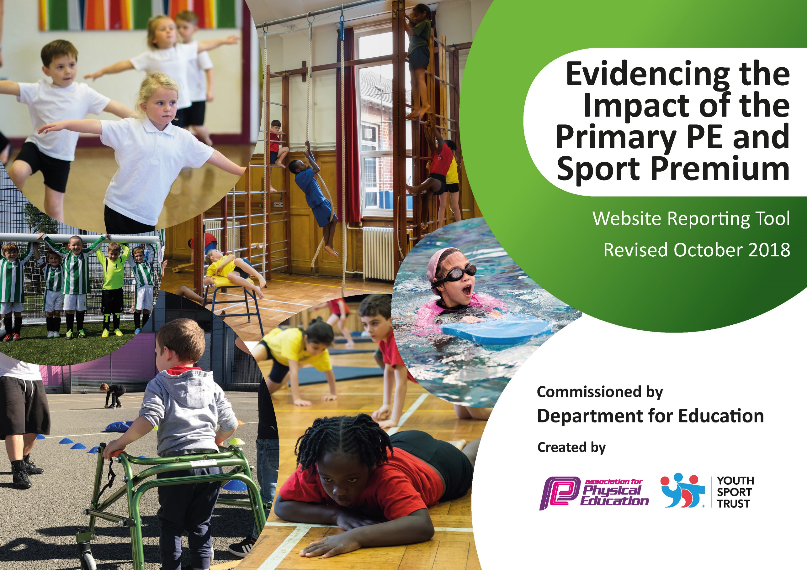
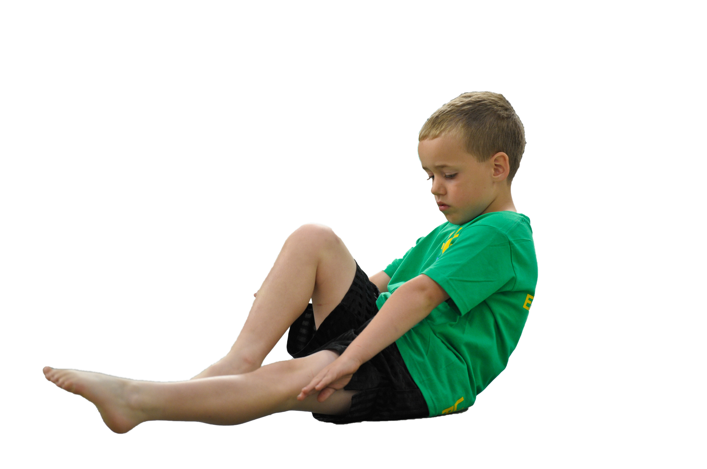
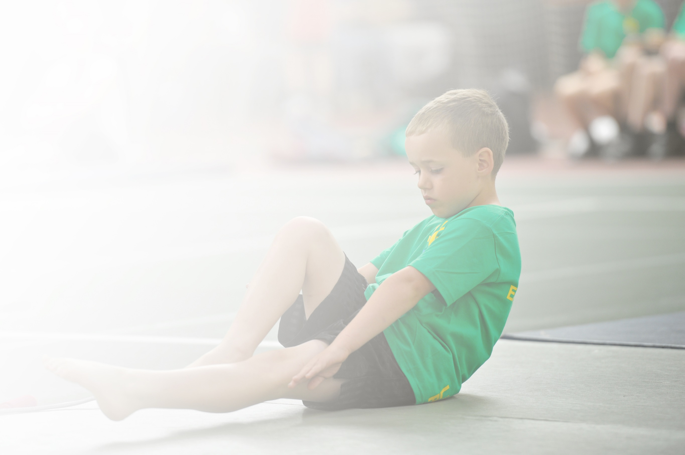
Schools must use the funding to make additional and sustainable improvements to the quality of Physical Education, Sport and Physical Activity (PESPA) they offer. This means that you should use the Primary PE and Sport Premium to:

- Develop or add to the PESPA activities that your school already offer
- Build capacity and capability within the school to ensure that improvements made now will benefit pupils joining the school in future years

Please visit gov.uk for the revised DfE guidance including the 5 key indicators across which schools should demonstrate an improvement. This document will help you to review your provision and to report
your spend. DfE encourages schools to use this template as an effective way of meeting the reporting requirements of the Primary PE and Sport Premium.

We recommend you start by reflecting on the impact of current provision and reviewing the previous
spend. Under the Ofsted Schools Inspection Framework, inspectors will assess how effectively leaders use the Primary PE and Sport Premium and measure its impact on outcomes for pupils, and how effectively governors hold them to account for this.

Schools are required to publish details of how they spend this funding as well as on the impact it has on pupils’ PE and sport participation and attainment by the end of the summer term or by 31 July 2019 at the
latest.
We recommend regularly updating the table and publishing it
on your website throughout the year, as evidence of your
ongoing review into how you are using the money to
secure maximum, sustainable impact. To see an
example of how to complete the table please
click HERE.

Support for review and reflection - considering the 5 key indicators from DfE, what development needs are a priority for your setting and your students now and why? Use the space below to reflect on previous spend, identify current need and priorities for the future.

Key achievements to date: | Areas for further improvement and baseline evidence of need:
- Achieving Sport Mark Silver, Hatfield does very well in attending sporting events and fixtures.  - Providing 42 extracurricular clubs delivering with a total of 725 attendances. Over a variety of different sports.  - Children have access to a qualified PE teacher and a variety of sports clubs coaches.  - Hatfield has great links with Sheffield Hallam University, Sheffield University and SWFC community programm. | - For all pupils leaving primary school to be physically literate and with the knowledge, skills and motivation necessary to equip them for a healthy, active lifestyle and lifelong participation in physical activity and sport.  - Introduce a greater variety of sports into the curriculum and increase community links with local clubs.  - To upskill class teacher and increase confidence in the delivery of high quality of PE.

Meeting national curriculum requirements for swimming and water safety | Please complete all of the below:
What percentage of your current Year 6 cohort swim competently, confidently and proficiently over a distance of at least 25 metres?  N.B. Even though your children may swim in another year please report on their attainment on leaving  primary school. | %
What percentage of your current Year 6 cohort use a range of strokes effectively [for example, front crawl, backstroke and breaststroke]? | %  Will acquire data through parent questionnaire
What percentage of your current Year 6 cohort perform safe self-rescue in different water-based situations? | % Will acquire data through parent questionnaire
Schools can choose to use the Primary PE and Sport Premium to provide additional provision for swimming but this must be for activity over and above the national curriculum requirements. Have you used it in this way? | No

Action Plan and Budget Tracking
Capture your intended annual spend against the 5 key indicators. Clarify the success criteria and evidence of impact that you intend to measure to evaluate for students today and for the future.

Academic Year: 2018/19 | Total fund allocated: £19,280 | Date Updated: 14/11/2018
Key indicator 1: The engagement of all pupils in regular physical activity – Chief Medical Officer guidelines recommend that primary school children undertake at least 30 minutes of physical activity a day in school |  |  |  | Percentage of total allocation:
 |  |  |  | 56%
School focus with clarity on intended impact on pupils: | Actions to achieve: | Funding allocated: | Evidence and impact: | Sustainability and suggested next steps:
High quality PE delivered across the school to develop physical literacy of all pupils.  Increase the opportunities given to children for daily physical activity at school  Active Lessons  Increased provision in the playground areas to increase pupil  engagement in physical activities  Improved Physical Education for  Foundation Stage to promote early  development of A daily walk.  Active travel / Breakfast | PE lead to support staff planning and delivering lessons to increase confidence and competence.  Healthy Owls program  SWFCCP PL Primary Stars-The vision of PL Primary Stars is to inspire all children to learn, be active and develop important life skills  PL Primary Stars aims to inspire girls and boys aged 5-11 in the classroom, the playground and on the sportsfield. Being active is at the heart of the programme.  Half termly active challenges, whole school fund raisers.  - Sponsored walk  - Inter-form games  - Football competitions  - Dance competitions  - Sports day  Each class ae having at least 1 active brainbreak per day. As staff confidence increased more active lessons, I moves, active maths and go noodle.  Playtimes used to increase children’s participation in a variety of physical activities. Purchase appropriate playground equipment to support this.  16 play leaders trained up to lead across lunch time / break and clubs  Research and then possibly implement additional 10 minute walk around the cricket field.  10 day challenge  Dr Bike | £10, 000  £300  £500  £0 (Imoves in last year’s budget – runs out Feb 2019)  Funds raised from sponsored walk.  Part of the Arches package see KPI 5 | Feedback from SWFC, lesson observations. Student voice.  Whole school taking part, support from parents, fund raising. Student voice.  Lesson observation, staff and student questionnaires.  School council to take ownership  Improved levels of fitness / concentration / sense of achievement  Photos | Teaching staff upskilled, from Team teaching with SWFC. We have use of resources and Schemes od work which can be reused.  Developed links with local cricket club with use of facilities FOC. Continue to build on community links  CPD and staff training.  Fundraising events  Ongoing training to Imrpove confidence of staff, using sports leaders.

Key indicator 2: The profile of PESSPA being raised across the school as a tool for whole school improvement |  |  |  | Percentage of total allocation:
 |  |  |  | 2%
School focus with clarity on intended impact on pupils: | Actions to achieve: | Funding allocated: | Evidence and impact: | Sustainability and suggested next steps:
To link PE to improving the  English and Mathematics outcomes/provision in the school.  Promote health and activity through display board to raise the profile of PE and sport for all visitors, staff and pupils to see.  Promoting achievement on website / social media  Play Leaders to be trained, allowing pupils to take on leadership roles to support physical activity at lunchtimes. – Development of a sports Crew  To raise the profile of  sport and activity across the school to inspire and motivate pupils to participate in PE and school sport. | Introduce the SWFC  Football Club Rising Stars programme across the school.  Delivered Y3 Autumn 1 /2  Delivered in Y5 spring 1 / 2  Delivered in y2 & y6 Summer term.  Activity timetable needs to be displayed in the main entrance.  Sports blogging once a week, keep community and parents updated to the children’s achievements in sport  More training delivered by PE lead. More recognition and responsibility.  Sports crew badges, fleece to be worn on the yard when leading  Half termly Celebration Assembly to include PE and sport achievements from both within school and out of school. Marvellous me a text messages sent to parents as well as social media. | £100  £200  £100 | The profile of sport will be raised and this will be liked to  improving outcomes in Reading,  Writing and Mathematics.  All after school clubs at 80% attendance or more. Waiting list for all clubs. Parent feedback  Sense of pride, student voice, photos.  Certificates given out in celebrations assembly, photos | The programme will be reviewed to assess its impact.  Teachers gaining confidence to lead own sports clubs, incentives from head teacher. Teachers paired with external coach learning specific sports so can run own club.  Resources already bought games to be played on the yard.  Part of whole school celebrations

Key indicator 3: Increased confidence, knowledge and skills of all staff in teaching PE and sport |  |  |  | Percentage of total allocation:
 |  |  |  | 4%
School focus with clarity on intended  impact on pupils: | Actions to achieve: | Funding  allocated: | Evidence and impact: | Sustainability and suggested  next steps:
Up-skilling staff to improve progress and achievement of all pupils  Access to CPD courses for specific knowledge. | PE lead to support staff in curriculum PE by modelling good practice.  PE lead to attend regular local training courses through Astrea Active conferences to broaden subject knowledge and opportunities offered to schools.  PE Lead to provide lesson plans and schemes of work.  SWFCCP coaches are deployed to support teachers’ development so that they can continue to provide high-quality sessions after the support ends, rather than replace or displace teachers.  CPD sessions available through SSCO partnership and Premier league.  Imoves | See KPI 1  £700 | Increased teacher confidence, skills audit, lesson observations, team teaching. Increase teacher knowledge.  High quality PE

Key indicator 4: Broader experience of a range of sports and activities offered to all pupils |  |  |  | Percentage of total allocation:
 |  |  |  | 26%
School focus with clarity on intended  impact on pupils: | Actions to achieve: | Funding  allocated: | Evidence and impact: | Sustainability and suggested  next steps:
Continue to improve extra-curricular provision by offering a wide range of clubs and activities in order to increase pupil participation. | Dance Dayz  Badminton  Tennis  Cricket  Sheffield Hallam  Sheffield University  Roller Hockey  Tennis  Multi-sports  Fitness  Gymnastics Clubs  Staff leading activities  Dr Bike | £5000

Key indicator 5: Increased participation in competitive sport |  |  |  | Percentage of total allocation:
 |  |  |  | 12%
School focus with clarity on intended  impact on pupils: | Actions to achieve: | Funding  allocated: | Evidence and impact: | Sustainability and suggested  next steps:
To provide pupils opportunities to participate in competitive sports to develop confidence and self-esteem.  Transport to competitons  Astrea Active  Active whole school | Subscription to the annual package of support from the Arches School Sport Partnership, providing links to a wide variety of sporting opportunities and inclusive activities.  - Pupil leadership  - Staff CPD  - Pupil participation in competitions  - School achievement of Silver Sports Mark  - Additional extra-curricular clubs  - Support for Sports Day  - Entry to Dance performance  Sports day / active challenges | £1880  £500

