Year 2 Homework Menu
Theme: Africa
Geography  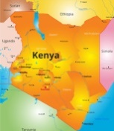  Be creative and artistic and create your own map of Kenya. Can you include the following:  - Draw and label 3 main cities  - Draw and label key rivers, mountains, lakes and plains  - Label surrounding seas | Dance  Listen to Rain, Rain, Beautiful Rain by the  artist Ladysmith Black Mambazo. Create a dance which shows the coming of the rain and the growing of the plants. | Art/DT  African masks form an important part of ceremonial costume. Design and create your own African mask.
Art/Science  Draw an African animal. Can you explain how they have adapted to their habitat? 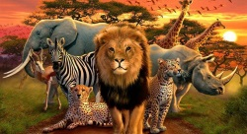 | ICT  Choose an endangered African animal and  make a poster to persuade people to join a  campaign to save it from extinction. | 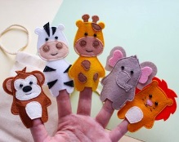  Art  Can you make an hand or finger puppet of an African animal.
DT  Find and try some traditional African food Can you write a recipe? | PSHE  Make a [poster of what a good friend is. | PE  Design your own invasion game. Make a  list of the rules and design the pitch or  court the game would be played on. What  equipment would be needed to play?
Complete a task and get your bingo card stamped.

3 tasks complete = 5 Dojos 6 tasks complete = a treat from the class dippy box 9 tasks complete = special certificate and prize

